|  |
| --- |
| TL Version: How to Enter Time into CYSH |

1. Go to CYSH via your [Okta Homepage](https://cityyear.okta.com/app/UserHome) (cityyear.okta.com)

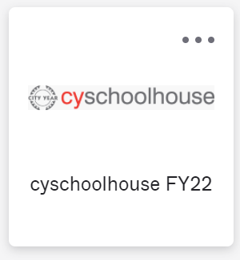

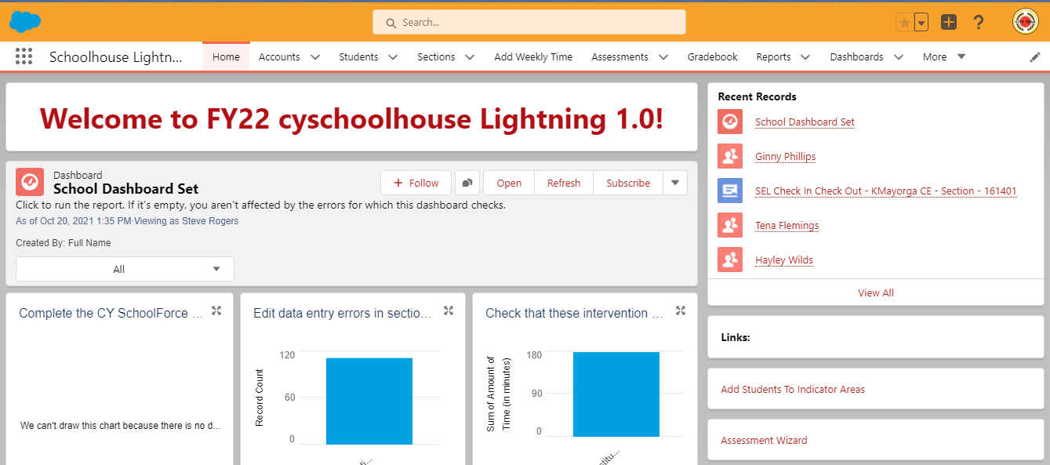

1. Select the Section tab on the ribbon

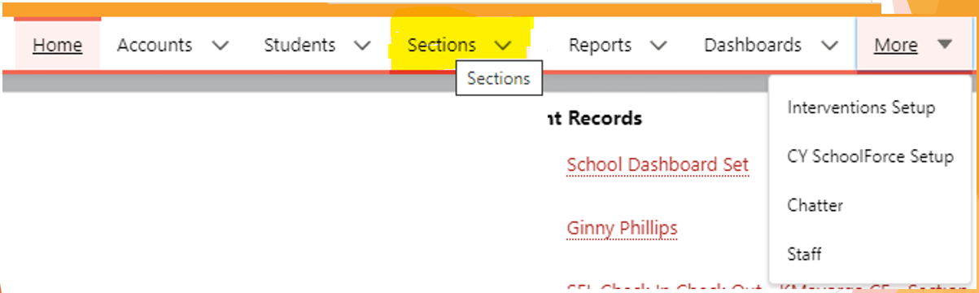

1. Find your section and click the section name (*Note: create a custom view to make it easier to find your sections, find section on page on how to create view.

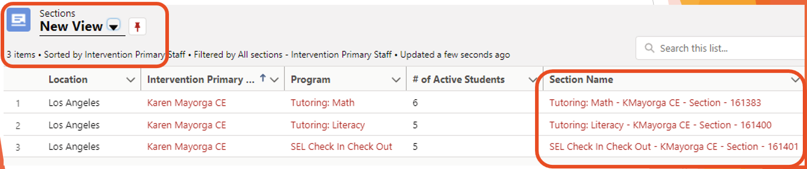

1. Select students for the session by clicking on the checkboxes next to their name and click Add Time

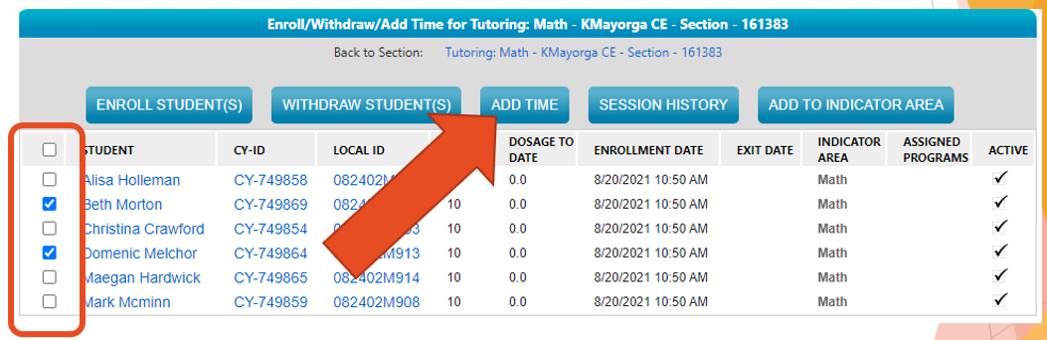

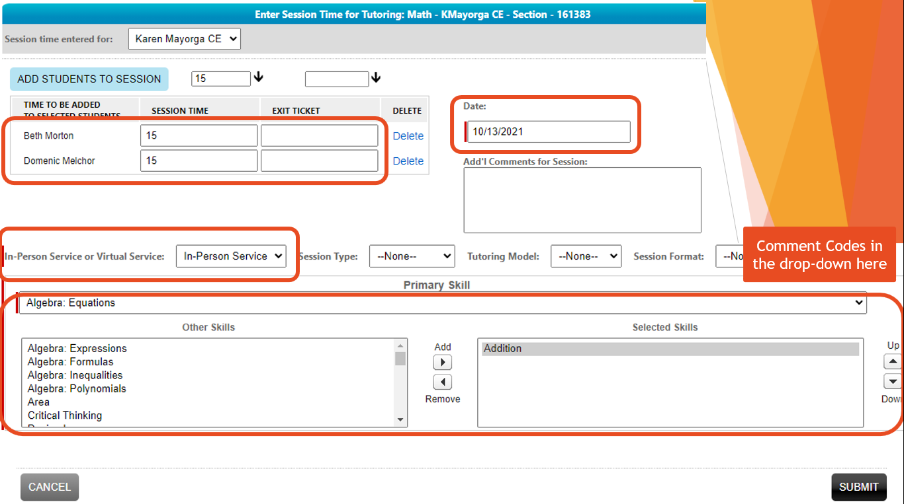

1. Enter the Session date, use the drop-down menu to select ‘In-Person’ service, select a comment code option from the Site Details drop-down menu, select a primary Skill and enter time spent with student in minutes. Then click Submit.